**Ideation Phase**

**Define the Problem Statements**

|  |  |
| --- | --- |
| Date | 31 January 2025 |
| Team ID | LTVIP2025TMID32623 |
| Project Name | Enchanted Wings: Marvels of Butterfly Species |
| Maximum Marks | 2 Marks |

**Customer Problem Statement Template:**

Butterflies are beautiful and ecologically important insects that help pollinate plants and indicate the health of our environment. However, identifying butterfly species can be difficult, especially for non-experts, due to the subtle differences in their colors, patterns, and sizes. This makes it hard for scientists, students, and nature lovers to monitor and protect them—especially rare or endangered species.

This project aims to build an AI-powered system that can automatically recognize different butterfly species from photos. By using machine learning and computer vision, the system will not only identify the species but also provide useful information about their habitat, conservation status, and ecological role. The goal is to make butterfly identification faster, easier, and more accessible—helping both research and conservation efforts.

**Example:**

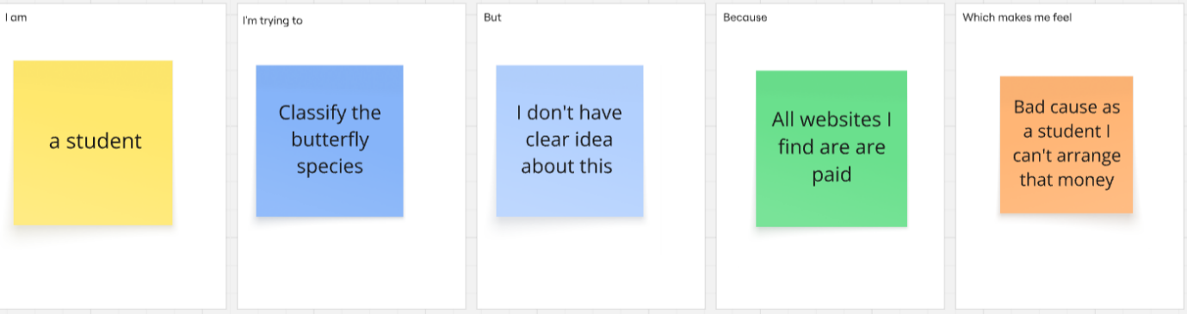

Reference: <https://miro.com/templates/customer-problem-statement/>

|  |  |  |  |  |  |
| --- | --- | --- | --- | --- | --- |
| **Problem Statement (PS)** | **I am** | **I’m trying to** | **But** | **Because** | **Which makes me feel** |
| PS-1 | A 30 years old man who researches on ml | Develop and research on enchanted wings of butterfly species | There are so many soecies like more than 17000 so I am confused | Of so many counting for the species | Confusing and I feel trouble little bit. |
| PS-2 | A student | Classify the butterfly species | I don’t understnd the idea of the concept | Most of the websites are full od ad and not helpful | So much trouble. |